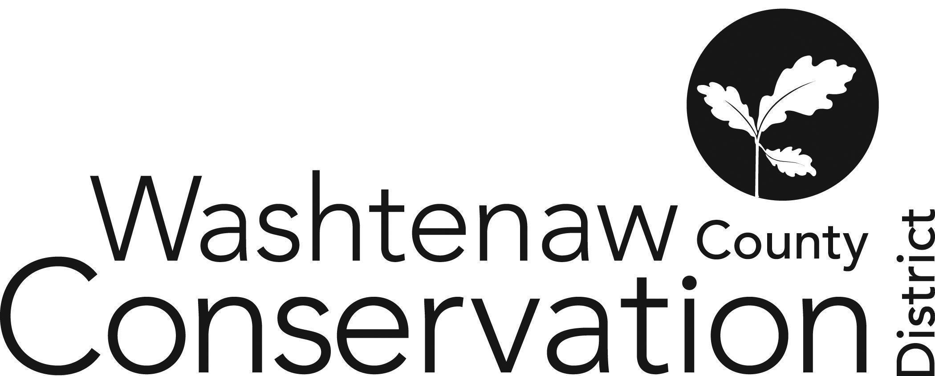

705 N. Zeeb Rd, Suite 201 Ann Arbor MI 48103-9506
Phone: (734) 302-8715 ed.wccd@macd.org
Web Site: www.washtenawcd.org

FEBRUARY BOARD MEETING MINUTES

The regular meeting was called to order at 6:03 pm on Thursday, February 26, 2026.

DIRECTORS PRESENT
Shannon Brines, Chair (Virtual)
Jill Dohner, Vice-Chair
Maegen Gabriel, Treasurer
Patricia Denig, Staff Liaison (Virtual)
Brandon Henes, Secretary

DIRECTORS/STAFF ABSENT

STAFF/OTHERS PRESENT
Summer Roberts, Executive Director (Virtual, until 6:30pm)

ADDITIONS TO AGENDA:
Moved Jill Dohner Oath of Office to 1st item and Q1 Budget Amendment to 2nd item. Notes are below.

OATH OF OFFICE
Jill Dohner Oath of Office received and acknowledged by BOD at start of meeting.
“I, Jill Dohner, do solemnly swear/affirm that I will support the Constitution of the United States and the Constitution of the State of Michigan, and that I will faithfully discharge the duties of the Office of a Conservation District Director, that includes upholding Conservation District Law, according to the best of my ability.”

PUBLIC COMMENT: None

COMMITTEE REPORTS
Finance Committee (Gabriel): New Treasurer attended first quarterly finance committee on 2/20/2026. Attendees: Deborah Shad, Summer Roberts, Wayne Oliver, Sara Farley.
HR Committee (Denig): Met on 2/6/2026 to discuss employee handbook and manual updates. Compensation study has been delayed. Attendees: Summer Roberts, Patricia Denig, Stephanie Benedict.
Leadership Committee (Brines): Met on 2/9/2026 to set agenda and discussed Finance Administrator position.
Farmer Committee (Gabriel): No meeting. MSUE event for diversifying crops was well attended.

MEETING MINUTES
Motion by Gabriel to approve the January meeting minutes. Seconded by Henes.
Vote: 3 yays, 0 nays.
Motion carried.

FINANCIAL REPORTS
As of January 31, 2026
Total Assets | $982,333.65
Total Liabilities & Equity | $982,333.65
Total Monthly Income | $67,314.43
Total Monthly Expense | $68,305.51
Total Monthly Other Income | $2,184.52
Total Monthly Net Income | $1,193.44

Discussion Highlights
- Script for Treasurer
- Mistake (date) on Budget vs. Actuals
  - Net income – actuals include AMP, TOPP adjustments
APPROVAL OF BILLS
Motion by Henes to approve payment of bills. Seconded by Gabriel.
Vote: 3 yays, 0 nays.
Motion carried.

CORRESPONDENCE
- MACD $1.6 million Erb Foundation Grant
- Loren Rullman, Werkner Road Widening
- Community Garden Demolition
- Genesee CD Single Federal Audit
PUBLIC NOTICES
No Discussion

FARMLAND AGREEMENTS & CONSERVATION PLANS
Motion by Gabriel to accept Conservation Plans. Seconded by Henes.
Vote: 3 yays, 0 nays.
Motion carried.

STAFF & PARTNER REPORTS
Executive Director – Summer Roberts
Conservation Specialist - Nick Machinski
Resource Specialist - Doug Reith
Development Manager - Megan Phillips Goldenberg (report added to Google Drive)
- Finance Administrator offboarding
- Davey Tree – supporting community events
- AMP/OSN Staffing
Community Forester - Matt DeJonge
Community Engagement Specialist – Jill Lada
Washtenaw County Farm Bureau - Sue Rodgers (no report)
Produce Safety Technician, Genesee CD – Micah Hutchinson
MDARD Regional Coordinator- Nadene Berthiaume
NACD Congressional & Executive Actions Report

OLD BUSINESS
- Budget Scenario Updates/Staff Changes (10 min) – Phillips Goldenberg
  - NRCS Position
    - TOPP -> Funding KS through 6/30/26; probably money in this budget to take her through end of FY
    - NACD -> Recently paid for last year’s TA grant. Applied on 1/8/2026; likely 1-2 months until notified
    - AMP -> KS interested in tech position; combined with OSN is 3 FTE through 2028
    - EGLE OSN -> 01/01/2026 spend dollars, but don’t have fully signed and executed contract
      - March 23rd is start date for the Specialist managing the 2 grants
      - Two techs will start later in the calendar year
      - Motion by Gabriel for staff to proceed with hiring new OSN/AMP staff despite EGLE OSN contract not being signed. Seconded by Henes. Vote: 3 yays, 0 nays. Motion carried.
    - Cooperative Agreement with NRCS
      - Email from MACD - no one has authority to do cooperative agreements
      - Solomon sent documents for Brines and Roberts to review; will include in March BOD meeting
  - Finance Administrator
    - Shazia Ansari, starting March 9th
  - Administrative Assistant
- Road Widening Update (2 min) – Brines
  - Brines followed up via email about BOD confusion on the matter
- Training Opportunities (5 min) - Brines
  - Save the Date: Legislative Action Day on March 11, 2026, Lansing, MI
    - Lada, Dohner, Phillips Goldenberg, Gabriel attending

NEW BUSINESS
- Board Director Oath of Office (5 min) – Dohner
  - See Oath of Office Section above.
- FY26 Q1 Budget Amendment (15 min) – Roberts
  - Discussion regarding new Finance Administrator and preparation for a single federal audit.
  - Additional expense line of “Operational Consultants” (i.e. consultants that benefit the entire District and cannot be tied to one program) to distinguish from “Program Consultants”.
  - Motion by Gabriel to accept the Q1 Budget Amendment. Seconded by Henes. Vote: 3 yays, 0 nays. Motion carried.
- Capitalization Policy (10 min) - Phillips Goldenberg
  - How we value, track, and account for durable goods (e.g. machines)
  - Current policy is from 2006
    - $500 or more have to track and depreciate
  - Federal grants have recommended threshold of $5,000 - $10,000
  - NACD TA Grant – allows for field supplies
    - Need camera that geolocates
  - Motion by Henes to increase the capitalization threshold from $500 to $5,000. Seconded by Gabriel. Vote: 3 yays, 0 nays. Motion carried.
- FY25 Compilation Report (10 min)
  - Discussion around omitted elements
  - Board would like Compilation added to next meeting, so they can review with Finance Administrator for improvements before FY26 audit
- Grant/MOU Updates (10 min) – Phillips Goldenberg
  - Upcoming grants/MOU
    - Ag Plastic Recycling Event MOU
      - Pilot using TOPP grant funding
    - MyFarms Digital Adoption
      - Staff member to support the implementation of a platform to track conservation practices and benefits
      - Erb Family Foundation -> TNC is going to be fiduciary
      - U-M Water Center will provide oversight
      - WCCD would host project staff
      - Application due in April; Fund for 10/1 (FY27)
  - Grant applications for BOD approval
    - MDARD Ag Regen
      - Moving forward with one group of farmers who will be implementing practices and then sharing results
      - Application due 2/27 at 5pm
  - Pending Notice
    - NACD TA
  - Grants for BOD Signature
    - EGLE OSN
  - Received in FY26 & uploaded to Google Drive
    - MDARD FY26 Grants: OPS, CS, CTAP, RAP
    - Saline-Macon (subawardee of RRWC)
    - County MOU Ag Tire Drive

NEXT MEETING:
- Regular Board Meeting: Thursday, March 26th at 6 p.m.

ADJOURNMENT: 8:04 PM
Motion by Henes to adjourn. Seconded by Gabriel.
Vote: 3 yays, 0 nays.
Motion carried.

THESE MINUTES STAND TO BE APPROVED.
MINUTES APPROVED
APPROVAL SIGNATURE: __________________________
ADJOURNMENT

