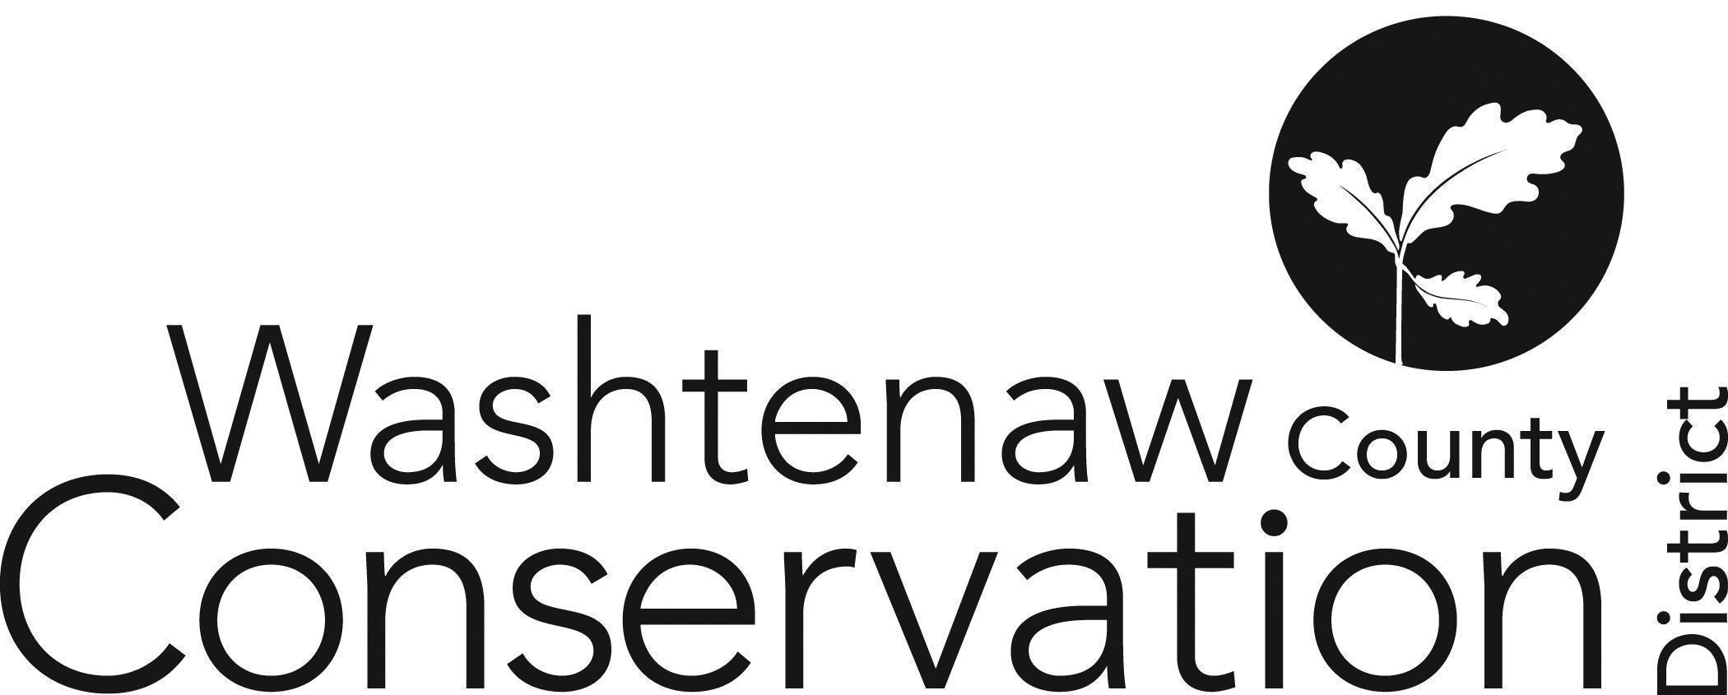

705 N. Zeeb Rd, Suite 201 Ann Arbor MI 48103-9506
Phone: (734) 302-8715 ed.wccd@macd.org
Web Site: www.washtenawcd.org

ZOOM LINK

MAY BOARD MEETING AGENDA

DATE: Thursday, May 15, 2025
TIME: 7 p.m.
PLACE: 705 N. Zeeb Rd, Ann Arbor, MI 48103 (Conference room 2010)

CALL TO ORDER – Brines

GUESTS/PUBLIC COMMENT-

ADDITIONS TO AGENDA –

APPROVAL OF MEETING MINUTES: April Board Meeting

COMMITTEE REPORTS -

MONTHLY FINANCIAL REPORT– Weber

APPROVAL OF BILLS - Brines

CORRESPONDENCE/PUBLIC NOTICES – Henes

FARMLAND AGREEMENT/PDR APPLICATIONS – Henes

CONSERVATION PLANS – Henes

STAFF REPORTS: Executive Director – Summer Roberts
Conservation Specialist - Nick Machinski
Resource Specialist - Doug Reith
Community Forester - Matt DeJonge
Outreach Coordinator- Anna Cone
Conservation Technician (MAEAP) – Paul Buzzard
Natural Resource Specialist (NACD) - Kristin Sutter
MiFarmLink Specialist- Jill Dohner
Development Manager - Megan Phillips-Goldenberg
Conservation Technicians (TOPP)- Kim Williams-Guillen & Alex Cacciari
NRCS District Conservationist - Solomon Andrews
Washtenaw County Farm Bureau- Sue Rodgers
Produce Safety Technician, Genesee CD – Micah Hutchinson
MDARD Regional Coordinator- Nadene Berthiaume
OLD BUSINESS
- Budget Scenario Updates/Staff Changes (10 min)
  - TOPP
    - Grant Cleared Federal Review!
    - Review MSU Subaward Contract
  - Community Engagement Specialist
- HR Policies Review (15 min)
  - Retirement Accounts - vesting schedule
  - BOD Resolution
- Maternity Leave Plan (20 min)

NEW BUSINESS
- Brief Review of Senator Shink Listening Session (5 min)
- Media and Letters of Support Policy (5 min)
  - Position Statements
- FY26 Compilation Engagement Letter (5 min)
- Knight Foundation Grant Memo (5 min)
- EGLE P Reduction Grant Memo (5 min)
- Annual Meeting Visioning (30 min)

NEXT MEETING:
- Monthly Board Meeting: Thursday, June 12 at 7 p.m.

ADJOURNMENT

