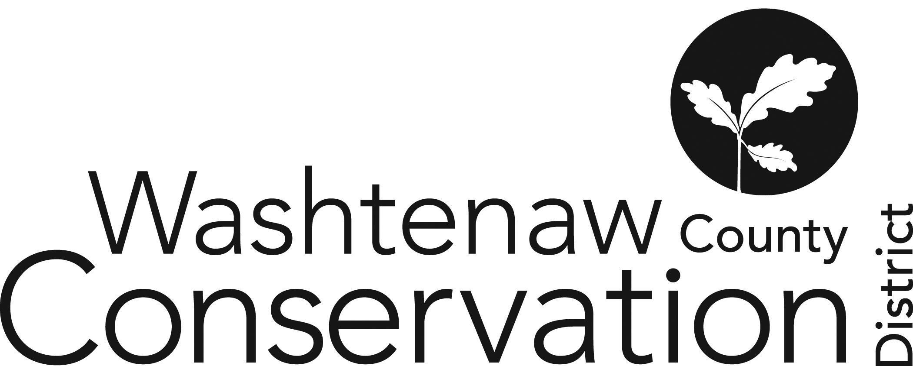

705 N. Zeeb Rd, Suite 201 Ann Arbor MI 48103-9506

Phone: (734) 302-8715 ed.wccd@macd.org

Web Site: [www.washtenawcd.org](http://www.washtenawcd.org)

[ZOOM LINK](https://us02web.zoom.us/j/84926938017?pwd=KzZNcmE3V3luNTZQdWVYQ2p3bkt1QT09)

**SEPTEMBER BOARD MEETING AGENDA**

**DATE:** Thursday, September 19, 2024

**TIME:** 7 p.m.

**PLACE:** 705 N. Zeeb Rd, Ann Arbor, MI 48103 (Conference room 2010)

**CALL TO ORDER –** Brines

**GUESTS/PUBLIC COMMENT-**

**ADDITIONS TO AGENDA –** Brines

**APPROVAL OF MEETING MINUTES:** August Monthly Board Meeting and August SPECIAL Board Meeting

**COMMITTEE REPORTS -**

**MONTHLY FINANCIAL REPORT–** Weber

**APPROVAL OF BILLS -** Brines

**CORRESPONDENCE/PUBLIC NOTICES –** Gabriel

**FARMLAND AGREEMENT/PDR APPLICATIONS –** Gabriel

**CONSERVATION PLANS –** Gabriel

**STAFF REPORTS:** Executive Director – Summer Roberts

Conservation Specialist - Nick Machinski

Resource Specialist - Doug Reith

Community Forester - *Hiring*

Outreach Coordinator- Dru Mark-Wilson

Outreach Coordinator- John Scaramucci

Conservation Technician (MAEAP)– Paul Buzzard

Conservation Technician (NACD)- Matt DeJonge

MiFarmLink Specialist- Jill Dohner

MCSFP Specialist- Megan Phillips-Goldenberg

Conservation Technicians (TOPP)- Kim Williams-Guillen & Alex Cacciari

NRCS District Conservationist - Solomon Andrews

Washtenaw County Farm Bureau- Sue Rodgers

Produce Safety Technician, Genesse CD – Micah Hutchinson

MDARD Regional Coordinator- Nadene Berthiaume

**OLD BUSINESS**

1. Values Retreat
   1. Facilitator
   2. Agenda/Goals
      1. Leadership Committee meet with facilitator
   3. Date/Time - Nov 14th from 2:30-8:30pm is winning date (14 responses)

2. Region 10 MACD Meeting Report

**NEW BUSINESS**

1. NRCS Civil Rights Responsibilities for Partners
2. FY25 Budget Hearing
3. FY24 Budget Amendment

**NEXT MEETING:** SPECIAL Board Meeting: Thursday, August 29 at 7 p.m.

**ADJOURNMENT**