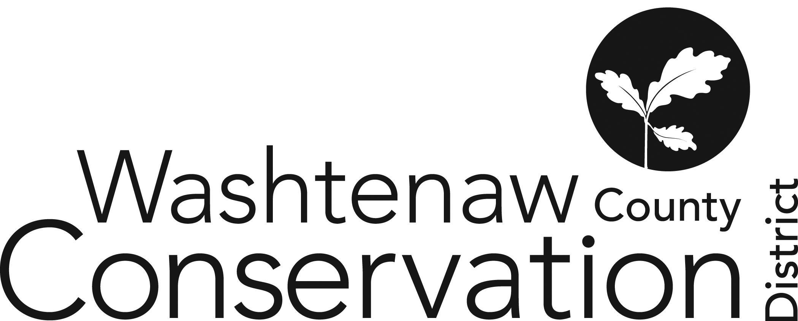

705 N. Zeeb Rd, Suite 201 Ann Arbor MI 48103-9506

Phone: (734) 302-8715 ed.wccd@macd.org

Web Site: [www.washtenawcd.org](http://www.washtenawcd.org)

[ZOOM LINK](https://us02web.zoom.us/j/84926938017?pwd=KzZNcmE3V3luNTZQdWVYQ2p3bkt1QT09)

**SPECIAL AUGUST BOARD MEETING AGENDA**

**DATE:** Thursday, August 29, 2024

**TIME:** 7 p.m.

**PLACE:** 705 N. Zeeb Rd, Ann Arbor, MI 48103 (Conference room 2010)

**CALL TO ORDER –** Brines

**GUESTS/PUBLIC COMMENT-**

**ADDITIONS TO AGENDA –** Brines

**APPROVAL OF MEETING MINUTES:** August Board Meeting

**OLD BUSINESS**

1. FY25 Draft Budget
2. Budget Adjustment vs. Amendment Process

**NEW BUSINESS**

1. Finance Committee Member

**NEXT MEETING:** September Board Meeting: Thursday, September 19 at 7 p.m.

**ADJOURNMENT**