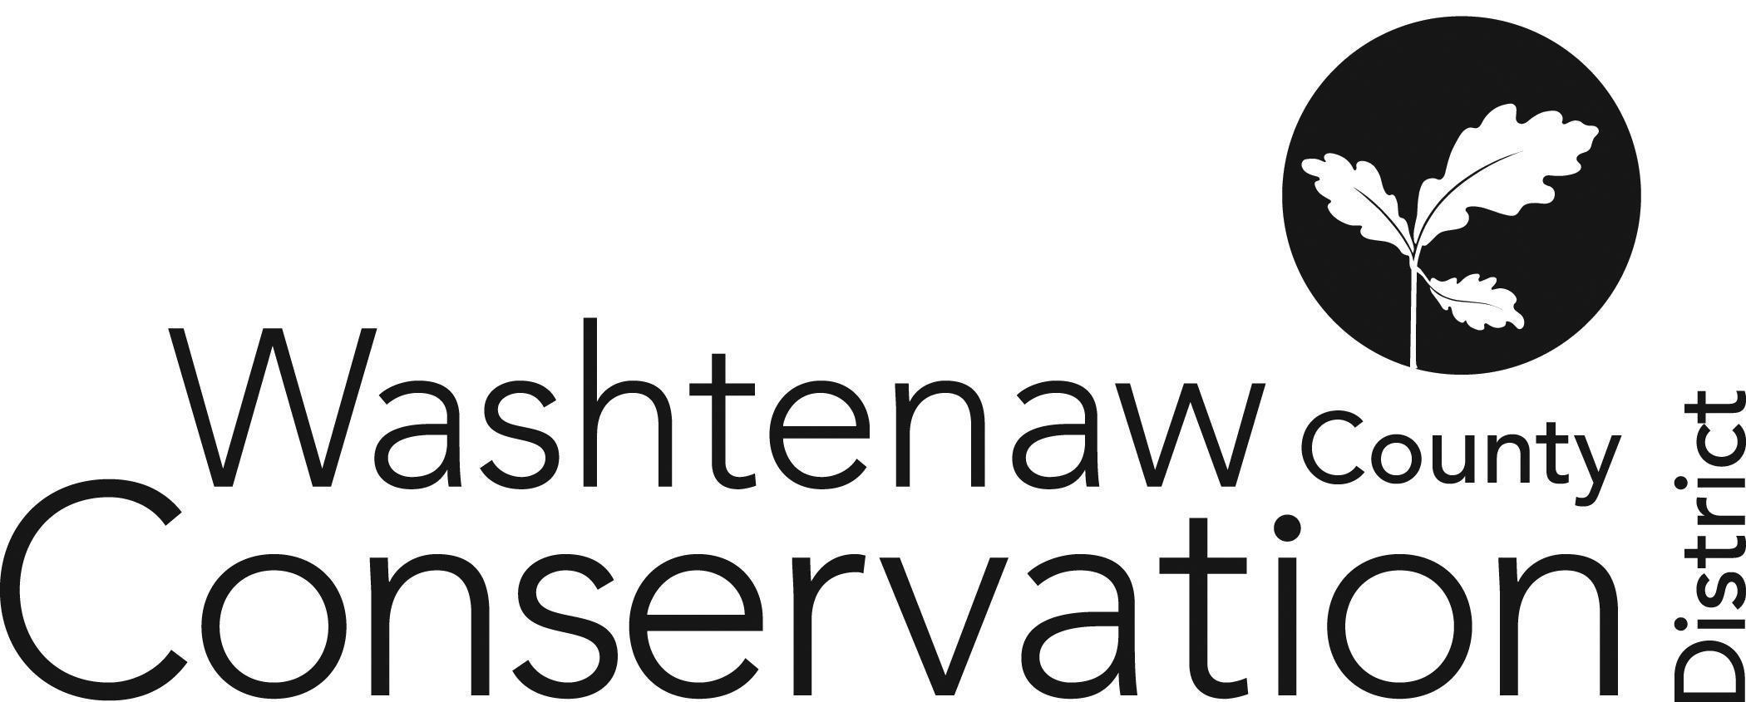

705 N. Zeeb Rd, Suite 201 Ann Arbor MI 48103-9506

Phone: (734) 302-8715 ed.wccd@macd.org

Web Site: [www.washtenawcd.org](http://www.washtenawcd.org)

[ZOOM LINK](https://us02web.zoom.us/j/84926938017?pwd=KzZNcmE3V3luNTZQdWVYQ2p3bkt1QT09)

**OCTOBER BOARD MEETING AGENDA**

**DATE:** Thursday, October 17, 2024

**TIME:** 7 p.m.

**PLACE:** 705 N. Zeeb Rd, Ann Arbor, MI 48103 (Conference room 2010)

**CALL TO ORDER –** Brines

**GUESTS/PUBLIC COMMENT-**

**ADDITIONS TO AGENDA –** Brines

MIFarmLink SARE Grant

**APPROVAL OF MEETING MINUTES:** September Monthly Board Meeting

**COMMITTEE REPORTS -**

**MONTHLY FINANCIAL REPORT–** Weber

**APPROVAL OF BILLS -** Brines

**CORRESPONDENCE/PUBLIC NOTICES –** Gabriel

**FARMLAND AGREEMENT/PDR APPLICATIONS –** Gabriel

**CONSERVATION PLANS –** Gabriel

**STAFF REPORTS:** Executive Director – Summer Roberts

Conservation Specialist - Nick Machinski

Resource Specialist - Doug Reith

Community Forester - Matt DeJonge

Outreach Coordinator- Dru Mark-Wilson

Outreach Coordinator- John Scaramucci

Conservation Technician (MAEAP)– *Hiring*

Natural Resource Specialist (NACD) - Kristin Sutter

MiFarmLink Specialist- Jill Dohner

MCSFP Specialist- Megan Phillips-Goldenberg

MCSFP Technicians - Paul Buzzard & Anna Cone

Conservation Technicians (TOPP)- Kim Williams-Guillen & Alex Cacciari

NRCS District Conservationist - Solomon Andrews

Washtenaw County Farm Bureau- Sue Rodgers

Produce Safety Technician, Genesee CD – Micah Hutchinson

MDARD Regional Coordinator- Nadene Berthiaume

**OLD BUSINESS**

1. MACD State Council and Fall Conference (10 min)
   1. Washtenaw Board Representative – Shannon Brines
   2. CDEM - Donation for silent auction?

**NEW BUSINESS**

1. K-12 Survey Results Presentation from Residential Programs Outreach Coordinator, Dru Mark-Wilson (20 min)
2. Annual Meeting (30 min)
   1. Awardee Criteria and Selection
      * 1. Small/Beginning Farmer of the Year
        2. Conservation Farmer of the Year
        3. Tree Conservationist of the Year
        4. Volunteer of the Year
        5. Distinguished Service Award?
   2. Door Prizes
   3. BOD Election
3. County MOU for Millage (10 min)
4. Schedule FY25 Board Meetings (5 min)
   1. Every Third Thursday of the Month
      * 1. Special Meeting on last Thursday in September?

**NEXT MEETING:** Monthly Board Meeting: Thursday, November 21 at 7 p.m.

**ADJOURNMENT**