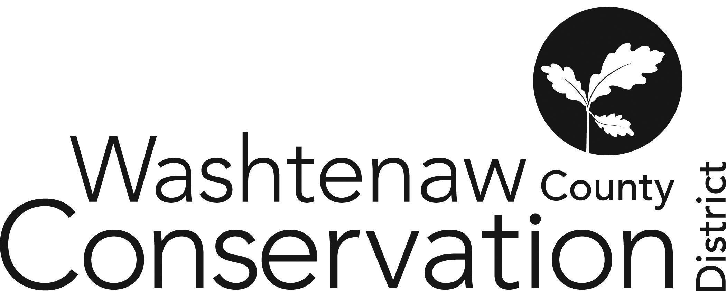

705 N. Zeeb Rd, Suite 201 Ann Arbor MI 48103-9506

Phone: (734) 302-8715 ed.wccd@macd.org

Web Site: [www.washtenawcd.org](http://www.washtenawcd.org)

[ZOOM LINK](https://us02web.zoom.us/j/84926938017?pwd=KzZNcmE3V3luNTZQdWVYQ2p3bkt1QT09)

**DECEMBER BOARD MEETING AGENDA**

**DATE:** Thursday, December 19, 2024

**TIME:** 7 p.m.

**PLACE:** 705 N. Zeeb Rd, Ann Arbor, MI 48103 (Conference room 2010)

**CALL TO ORDER –** Brines

**GUESTS/PUBLIC COMMENT-**

**ADDITIONS TO AGENDA –**

**APPROVAL OF MEETING MINUTES:** November Monthly Board Meeting

**COMMITTEE REPORTS -**

**MONTHLY FINANCIAL REPORT–** Weber

**APPROVAL OF BILLS -** Brines

**CORRESPONDENCE/PUBLIC NOTICES –** Gabriel

**FARMLAND AGREEMENT/PDR APPLICATIONS –** Gabriel

**CONSERVATION PLANS –** Gabriel

**STAFF REPORTS:** Executive Director – Summer Roberts

Conservation Specialist - Nick Machinski

Resource Specialist - Doug Reith

Community Forester - Matt DeJonge

Outreach Coordinator- Dru Mark-Wilson

Outreach Coordinator- *Vacant*

Conservation Technician (MAEAP)– John Scaramucci

Natural Resource Specialist (NACD) - Kristin Sutter

MiFarmLink Specialist- Jill Dohner

MCSFP Specialist- Megan Phillips-Goldenberg

MCSFP Technicians - Paul Buzzard & Anna Cone

Conservation Technicians (TOPP)- Kim Williams-Guillen & Alex Cacciari

NRCS District Conservationist - Solomon Andrews

Washtenaw County Farm Bureau- Sue Rodgers

Produce Safety Technician, Genesee CD – Micah Hutchinson

MDARD Regional Coordinator- Nadene Berthiaume

**OLD BUSINESS**

1. Values Retreat (5 min)
2. Annual Meeting (10 min)
   1. Door Prizes
      1. Gabriel: Agricole and Garden Mill
      2. Weber: Green Things Farm Collective and Argus
      3. Nolan: Chelsea Farm Supply and Dexter Mill
   2. BOD Roles
      1. Staff set-up at 3pm; Stay for clean up?; Any Board members available?
      2. Main Emcee - Brines
      3. Departing BOD - Matt Nolan, Tom Shanahan
3. County MOU for Millage (5 min)
4. Friends of WCCD Subcommittee - January 23 (5 min)
5. Budget Scenarios Subcommittee - January 7th (5 min)
6. Website Rollout - December 12th (2 min)
7. EGLE GLRI WLEB Cost Share Draft Grant (10 min)
8. MAWG Grant (5 min)

**NEW BUSINESS**

1. Presentation from Conservation Specialist, Nick Machinski (30 min)

**NEXT MEETING:**

1. Annual Celebration, Thursday, January 16th, 2025 at 5pm at Cobblestone Farm
2. Monthly Board Meeting: Thursday, January 23 at 7 p.m.

**ADJOURNMENT**