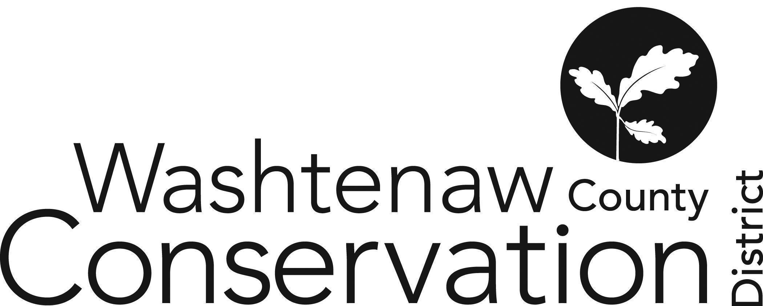

705 N. Zeeb Rd, Suite 201 Ann Arbor MI 48103-9506

Phone: (734) 302-8715 ed.wccd@macd.org

Web Site: [www.washtenawcd.org](http://www.washtenawcd.org)

[ZOOM LINK](https://us02web.zoom.us/j/84926938017?pwd=KzZNcmE3V3luNTZQdWVYQ2p3bkt1QT09)

**APRIL BOARD MEETING AGENDA**

**DATE:** Thursday, April 17, 2025

**TIME:** 7 p.m.

**PLACE:** 705 N. Zeeb Rd, Ann Arbor, MI 48103 (Conference room 2010)

**CALL TO ORDER –** Brines

**GUESTS/PUBLIC COMMENT-**

**ADDITIONS TO AGENDA –**

**APPROVAL OF MEETING MINUTES:** March Board Meeting

**COMMITTEE REPORTS -**

**MONTHLY FINANCIAL REPORT–** Weber

**APPROVAL OF BILLS -** Brines

**CORRESPONDENCE/PUBLIC NOTICES –** Henes

**FARMLAND AGREEMENT/PDR APPLICATIONS –** Henes

**CONSERVATION PLANS –** Henes

**STAFF REPORTS:** Executive Director – Summer Roberts

Conservation Specialist - Nick Machinski

Resource Specialist - Doug Reith

Community Forester - Matt DeJonge

Outreach Coordinator- Anna Cone

Conservation Technician (MAEAP)– John Scaramucci/Paul Buzzard

Natural Resource Specialist (NACD) - Kristin Sutter

MiFarmLink Specialist- Jill Dohner

Development Manager/MCSFP Specialist- Megan Phillips-Goldenberg

Conservation Technicians (TOPP)- Kim Williams-Guillen & Alex Cacciari

NRCS District Conservationist - Solomon Andrews

Washtenaw County Farm Bureau- Sue Rodgers

Produce Safety Technician, Genesee CD – Micah Hutchinson

MDARD Regional Coordinator- Nadene Berthiaume

**OLD BUSINESS**

1. Budget Scenario Updates/Staff Changes (10 min)
   * 1. TOPP
        1. Leave of Absence starting 04/07/2025 until 05/04/2025
        2. BOD approval of extension if needed?
     2. Community Engagement Specialist
        1. Hiring Process Exception
2. County MOU for Millage (2 min)
3. Newaygo Nursery (2 min)
4. HR Policies Review (20 min)
   * 1. Sick Leave
     2. Retirement/Deferred Compensation - take effect with move to MERS
        1. Impact of Partial Plan Termination rules?
5. FY24 Audit (10 min)
   * 1. Resolution: Review and Approve
6. Maternity Leave Plan (10 min)

**NEW BUSINESS**

1. Letters of Support (5 min)
   1. GLRI Letter
2. Farm Bureau Meeting Review (10 min)
3. MDARD OPS – BOD Governance Element Review (15 min)
4. Tree Sale Overview - volunteers (2 min)
5. MACD Conference (2 min)
   * 1. December 7-10, 2025 at Shanty Creek in Bellaire, MI

**NEXT MEETING:**

1. Monthly Board Meeting: Thursday, May 15 at 7 p.m.

**ADJOURNMENT**